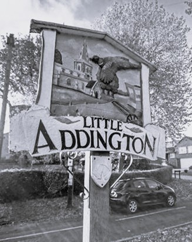
HAVE YOUR SAY NOW!

Dear Fellow Villager.
This letter is to introduce you to the Little Addington Neighbourhood Plan. The first stage is to collect the views of villagers through a survey. The best way to complete the survey is on-line. Just use the QR code or link at the bottom of this letter and they will take you directly to the website.
The Neighbourhood Plan is important. It gives you the opportunity to shape future of developments around our village, to protect important green spaces and safeguard the quality of the environment and community for future generations.
Your voice will be heard. When the Neighbourhood Plan has been completed and submitted to North Northamptonshire Council it will form part of the overall development plan for the area.
The survey will close on 31st March. The more completed questionnaires received the clearer the vision will be and the more authority the Little Addington Neighbourhood Plan will have.
What happens next? The information gathered from this survey will form the basis of the Neighbourhood Plan. The Neighbourhood Plan Steering Group will compile this information into a document which will be presented back to the community for feedback and comment.
Don’t put off filling in the questionnaire. All members of your household, including younger members, may complete the questionnaire. please telephone 01933 651326 or email jcocks@littleaddingtonparishcouncil.gov.uk if you need a paper copy of the questionnaire or help filling it in.
If you are interested in helping to shape the future of your community, please contact James Cocks from the Steering Group to discuss how you can help.
With Best Wishes

James Cocks
Little Addington Neighbourhood Plan Steering Group

This survey is optimised for completion online.
The online survey is quicker, easier, more accurate and safer. So please complete the survey online if you can at:
https://www.surveymonkey.com/r/LittleAddingtonNP
The following QR code can be read using a smartphone or other device to take you straight to the online survey.


Mail out 2nd March
Posters 9th March
Follow up door drop 16th March
Close on 30th

